Expermint-1

1. **Design DFA to accept bcaaaaaaaaaaaaaa, bc, and c**

bcaaaaaaaaaaaaaa

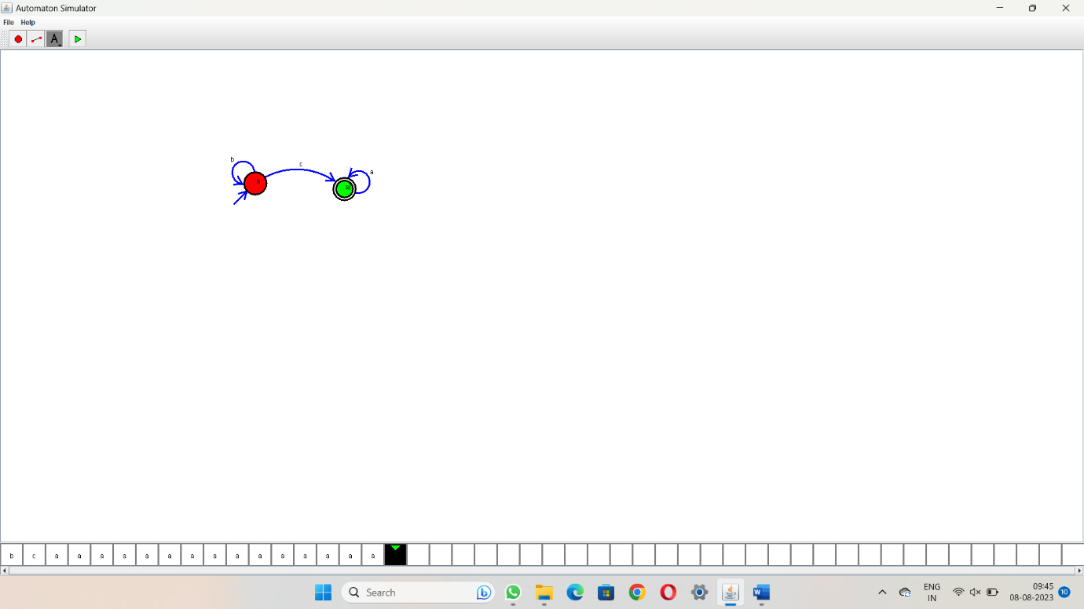

**2.Design NFA to accept aaaaaa**

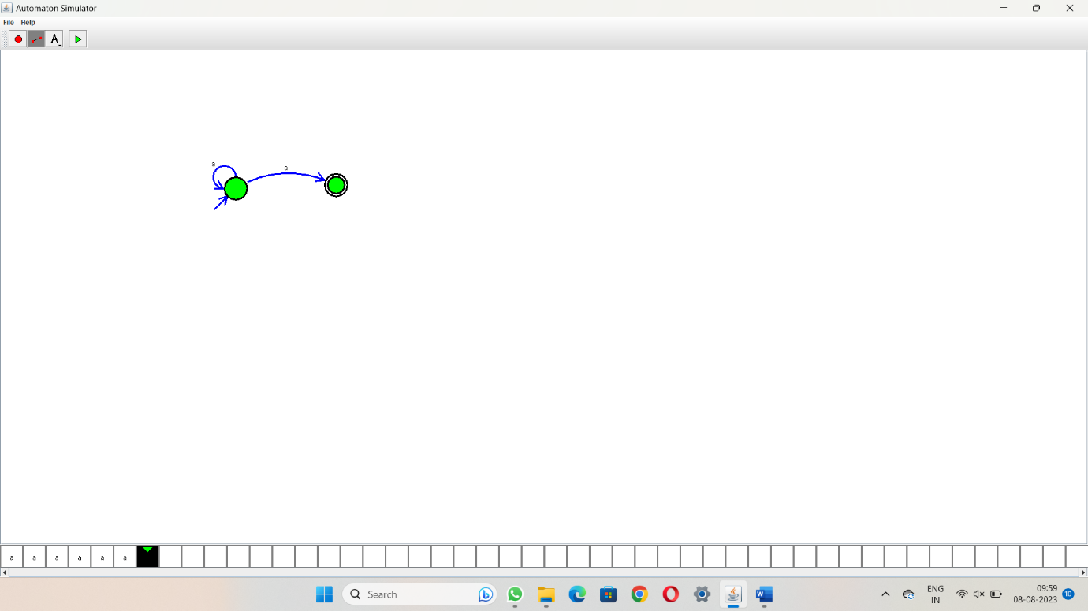

**3.Design PDA for the input a^nb^n**

**4.Design Tm For input a^nb^n**

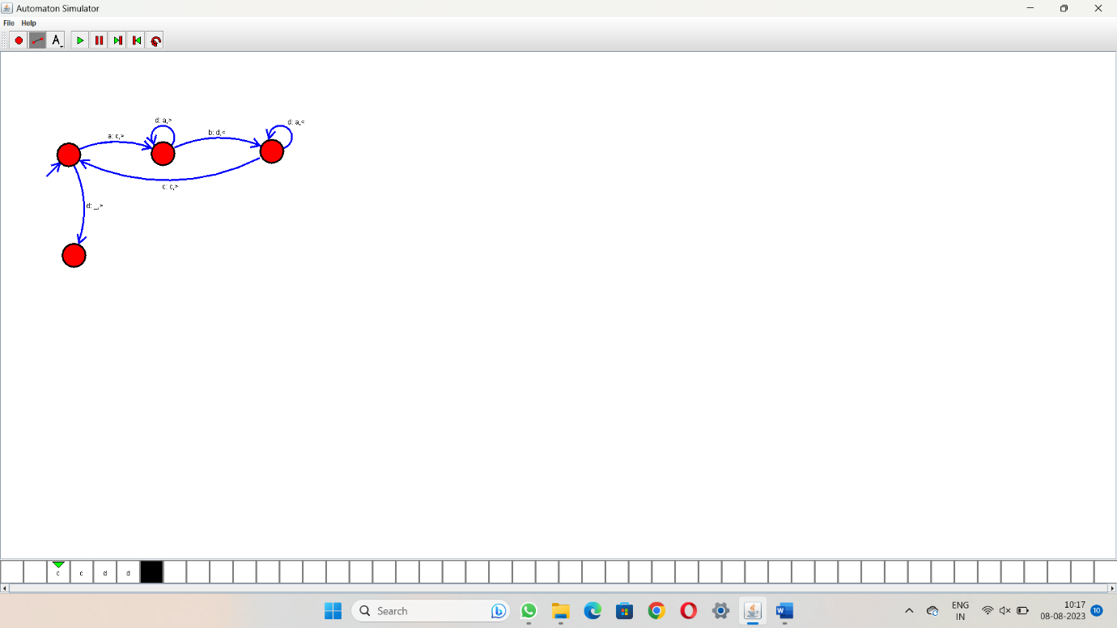

**5 .Design PDA for input aabbbbc ( L=a^nb^2n)**

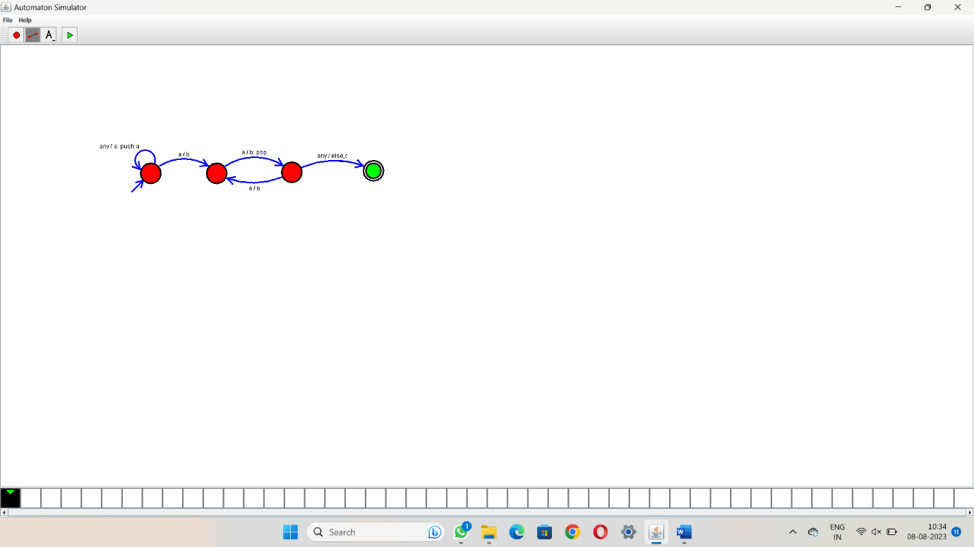

**6.TM Simulation for Palindrome W= ababa c**

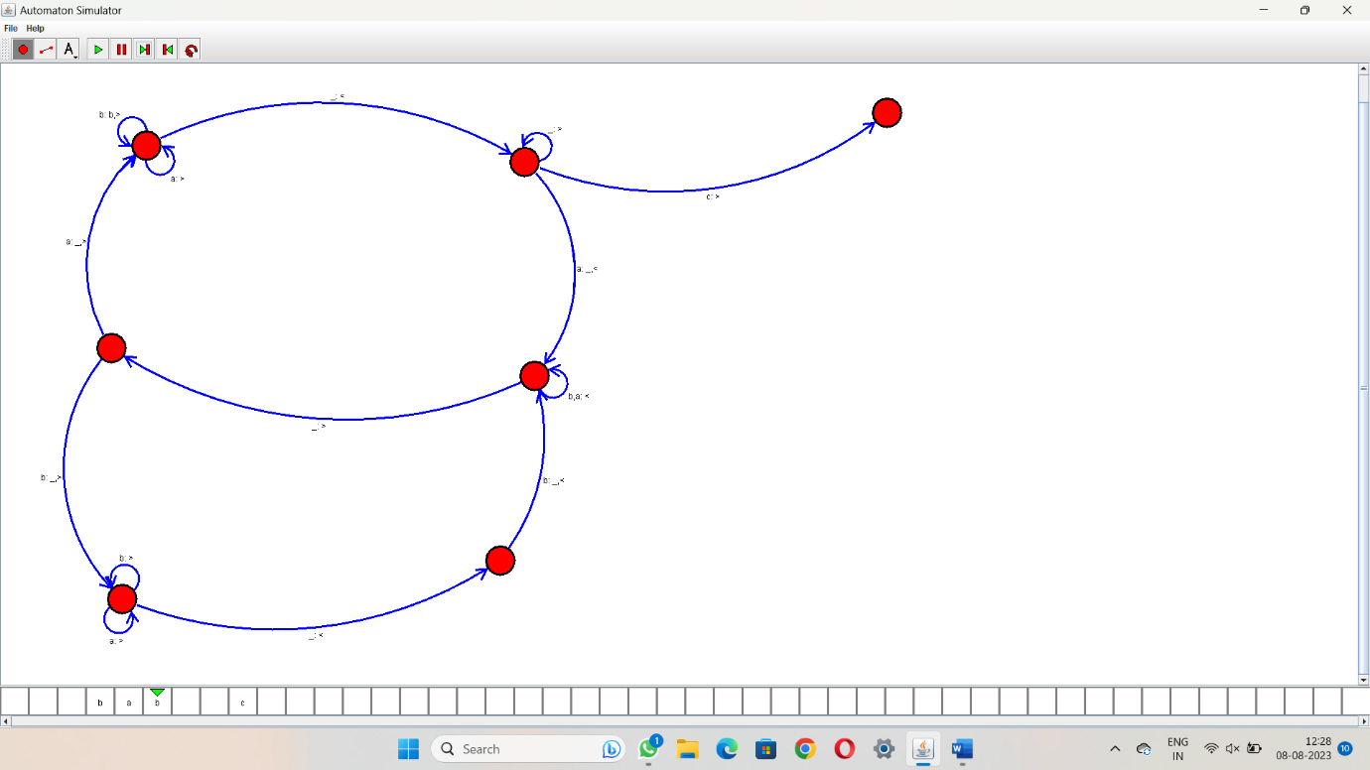

**7.Design TM to perform addition of following**

W= aa + aaaa

After Addition of a’s = aaaaaa

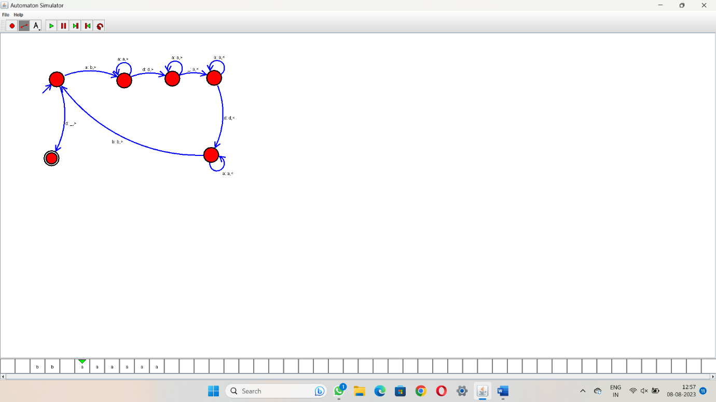

**8.Design TM to perform subtraction**

W= aaa-aa

The Result of Subtraction is = a

